H.T No
Regulations:
A15

Sreenidhi Institute of Science and Technology
(An Autonomous Institution)
Code No: 5CC57 Date: 01-Oct-2021(FN)

B.Tech III-Year I- Semester External Examination, Sept/Oct - 2021 (Supplementary)
FUNDAMENTALS OF SIGNALS AND SYSTEMS (EEE)

Time: 3 Hours Max.Marks:75

Note: a) No additional answer sheets will be provided.
b) All sub-parts of a question must be answered at one place only, otherwise it will not be valued.
c) Missing data can be assumed suitably.

ANSWER ANY 5 OUT OF 8 QUESTIONS. EACH QUESTION CARRIES 15 MARKS.

Bloom's Cognitive Levels of Learning (BCLL)

Remember | L1 | Apply | L3 | Evaluate | L5
Understand | L2 | Analyze | L4 | Create | L6

 |  |  | BCLL | CO(s) | Marks
1. | a) | Derive the expression for evaluating the mean square value of error from fundamentals. | L3 | CO1 | [8M]
 | b) | Explain the concepts of unit step function and Signum function with necessary diagrams. | L2 | CO1 | [7M]
2. | a) | Obtain the Fourier series of the following signal  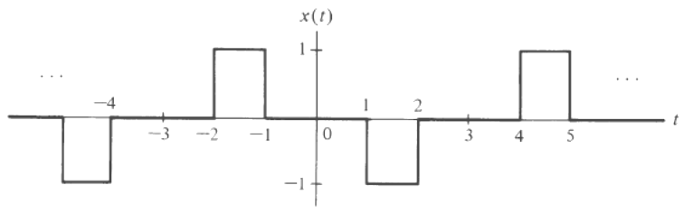 | L4 | CO2 | [8M]
 | b) | State and prove the time Shifting and time Differentiation properties of Fourier Transform. | L1 | CO2 | [7M]
3. | a) | Write short notes on the Ideal filters characteristics. | L1 | CO3 | [8M]
 | b) | Write short notes on Filter characteristics of a linear system. | L1 | CO3 | [7M]
4. | a) | Two subsystems and are connected in cascade. Using graphical interpretation of convolution find the overall transfer function | L3 | CO4 | [8M]
 | b) | Find the Laplace Transform of the following periodic signal  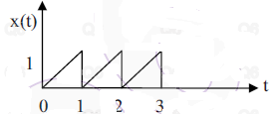 | L5 | CO4 | [7M]
5. |  | Explain the following:  - Flat top sampling  - Natural sampling  - Reconstruction of signal from samples. | L2 | CO5 | [15M]
6. | a) | Define ROC of Z-transform and list the properties of ROC of Z-transforms | L1 | CO6 | [8M]
 | b) | Find the inverse z-transform of the following function  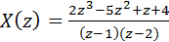; ROC: | L5 | CO6 | [7M]
7. | a) | Test the orthogonality of the signals sin(ωt) and cos(2ωt) over the interval t₀ to t₀+T. | L3 | CO1 | [5M]
 | b) | Find the Fourier transform of a constant, "A". | L5 | CO2 | [5M]
 | c) | Discuss on linearity and time invariant properties of a system with examples. | L1 | CO3 | [5M]
8. | a) | Derive the relation between auto-correlation function and Energy Spectral Density. | L3 | CO4 | [8M]
 | b) | What is Aliasing or frequency folding effect? Explain. | L2 | CO5 | [7M]

-- 00 -- 00 –

